**DOCUMENTATION OF THE CODE FOR ONLINE LIBRARY MANAGEMENT**

As an assignment given for an OOP unit, after one writes the source code he/she should include the test file an a documentation attached to easen explanation t ll cost

We therefore start by breaking down the codes to smaller part which is explainable

**1.Include headers**

They bring necessary libraries for a program to function.

In our code we used the following;

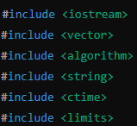

* #include <iostream> is used for input and output operations only
* #include <vector> provides dynamic array that can change size of a class as needed
* #include <algorithm> has algorithms that operate the ranges of elements
* #include <string> provides support to a class whereby it can handle texts
* #include <ctime> used to manipulate real time date and time
* #include <limits> defines characteristics of fundamental numeric types

**2.Declaring of the Namespace**

This directive allows you to use all entities in the standard namespace without prefixing them with “std::”



**3.Creating the first class “Book”**

This class represents a book in the class.

It encapsulates detail of a book and provides methods to access and modify these details

It has two parts:

**Private Members**

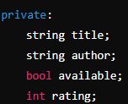

* It has string title; that stores the title of the book.
* It has string author; that stores the author of the book.
* It has bool available; that indicates whether the book is available for borrowing.
* It has int rating; that stores the rating of the book.

**Constructor**



It initializes the book with a title and an author in the default mode the book is available and has a rating of 0.

**Public Methods**

This method allows access to book’s details and tries to modify its availability abd ratings



**4.creating the second class “Library”**

This class managesa collection of books and provide various methods for a library operation

**Private Members**



It has the above code that stores a collection of ‘Book’ objects

**Public Methods**

This method allows ot to manage a collection of books and also interact with the library

**Adding a Book to the class**



The above code tries to add a new book to the library collection

**Searching for the Books by Title**

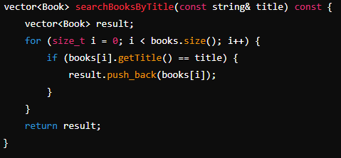

The above code helps in searching for a book in the library by it’s title,it also iterates through the collection and adds books with the matching title to the result vector

**Borrowing of a book**

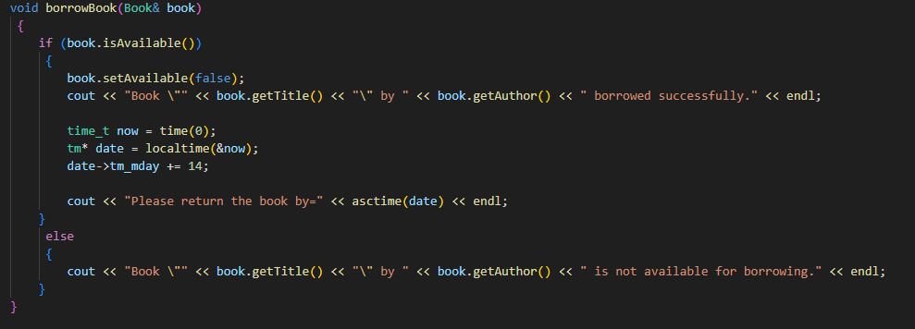

This allows the user to borrow a book if it is available, it checks the availability sets it to unavailable if it can’t be borrowed and also calculate for him the date to return

**Listing all Available Books in the Library**

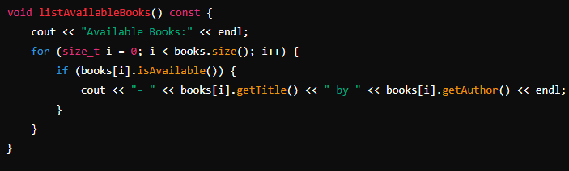

This method iterates through all the collection available and prints all of the required details

**5.Main Function Initialization**

This is the entry point of the program, It initializes the library, add the necessary books and at the end it handles user interactions fro borrowing and returning the book

**Initializing the Library**

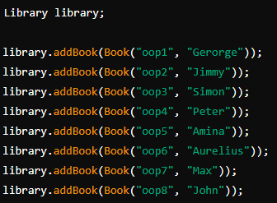

The code above creates a “Library” object and adds several books to it

**User interaction**

The code welcomes the user to the library and asks him if he has ever borrowed a book before

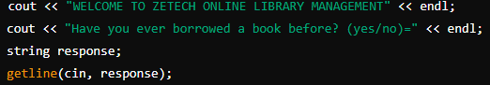

**If the User Hasn’t Borrowed Before**

This code allows the user to see the list of available books ans allow them to borrow any available

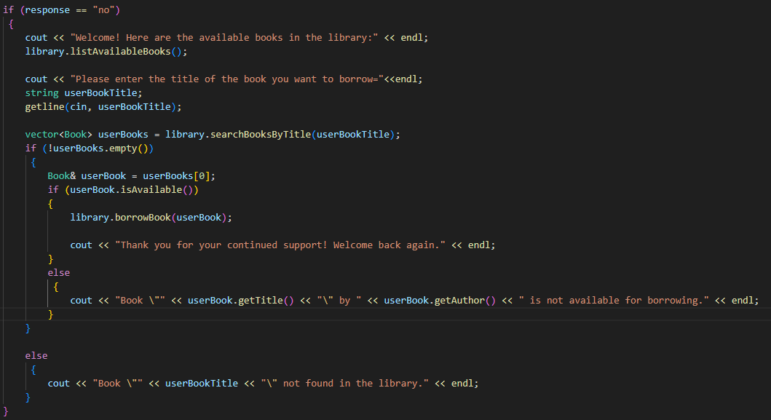

**If the User Has Borrowed Before**

This handles returning of the books which he had borrowed earlier

Calculate any late day and pose a charger of 20$ to each extra day after 14 days from the day borrowed

It also allows the user to rate thr book he had previously borrowed

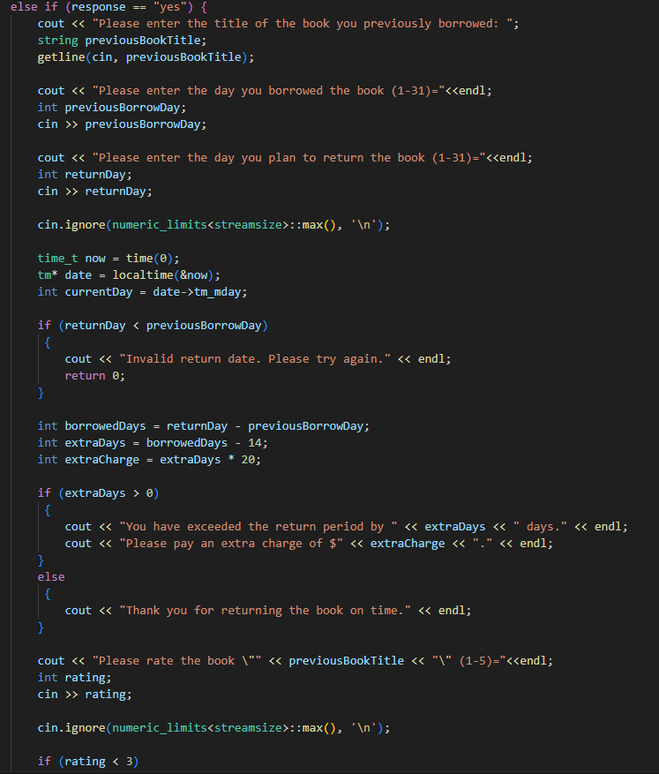

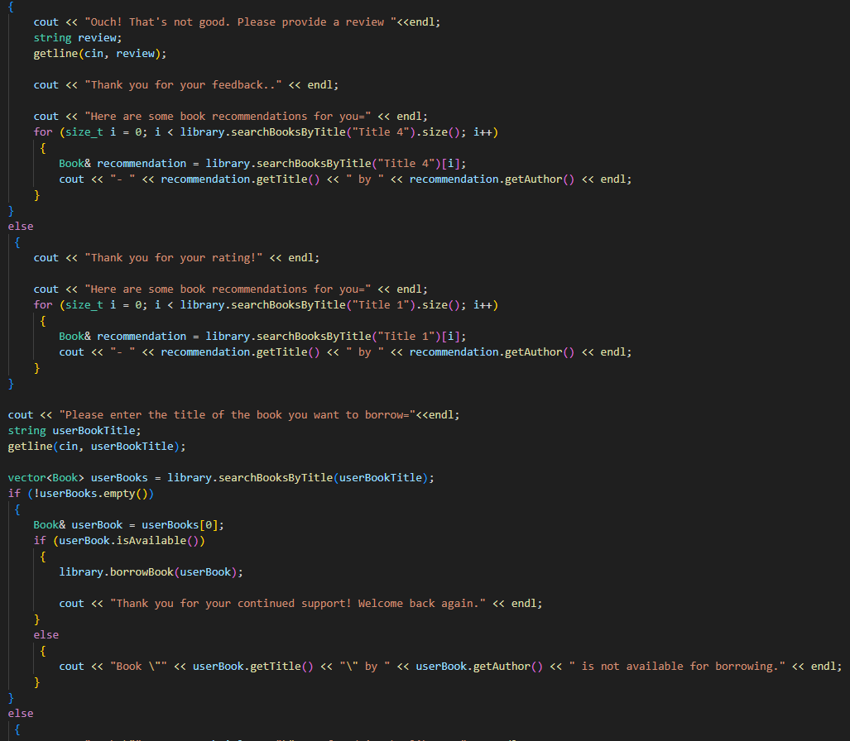

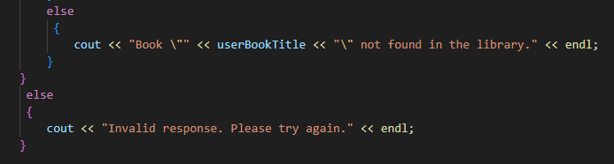

**Ending the Program**

This return 0 line indicates that the program is finished successfully



*This detaled breakdown covers each part of the code and explains their purpose and functionality with the relevant code snippets*

*It provides a comprehensive and complex understanding of the library management system making it easier for any user using it to grasp the logic and the flow of the program*

**THE OUTPUT**

